Day 14&15 - Task06 - Git&Github01
- Create a github account
  - Open github.com, and follow all the prompts and create an account with an email.
  - Set the default email and choose it as your public email
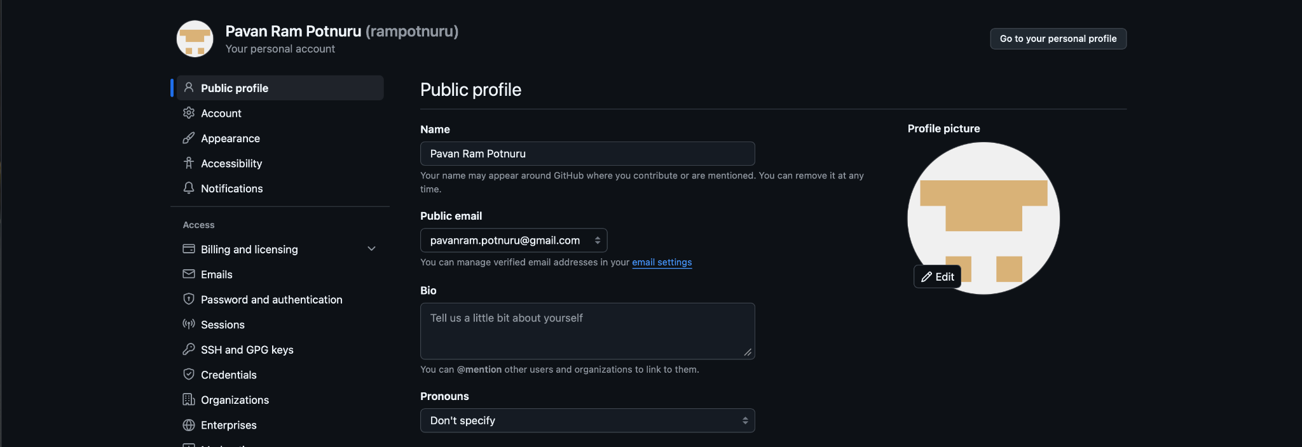
- Set up MFA (Multi-Factor Authentication) for the GitHub account using a mobile app.
  - Open settings to set-up a 2 factor authentication for your github account
  - You can either set-up different sign-up methods like an pass key or set-up a MFA using third party authenticators.
  - Below is a screenshot containing multiple sign-in option I’ve set up for my github account
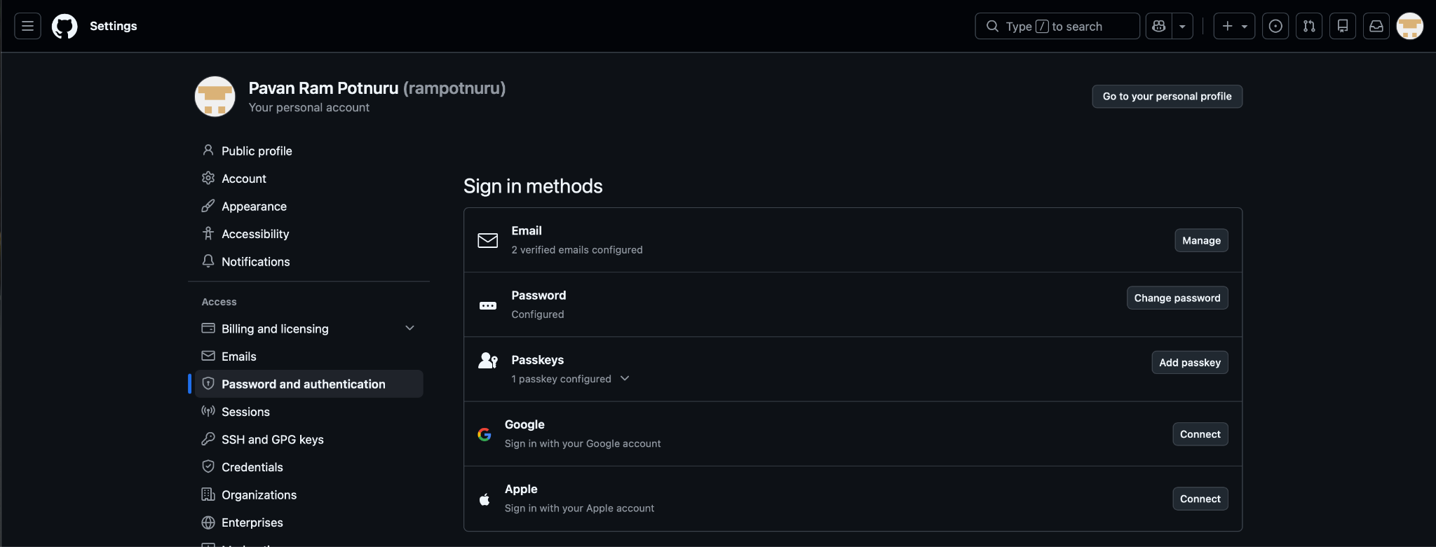

  - If you scroll down, you’ll get options to set MFA’s using third-party Authenticators
  - In my scenario, I’ve used Google Authenticator as my third party authenticator to set-up MFA.
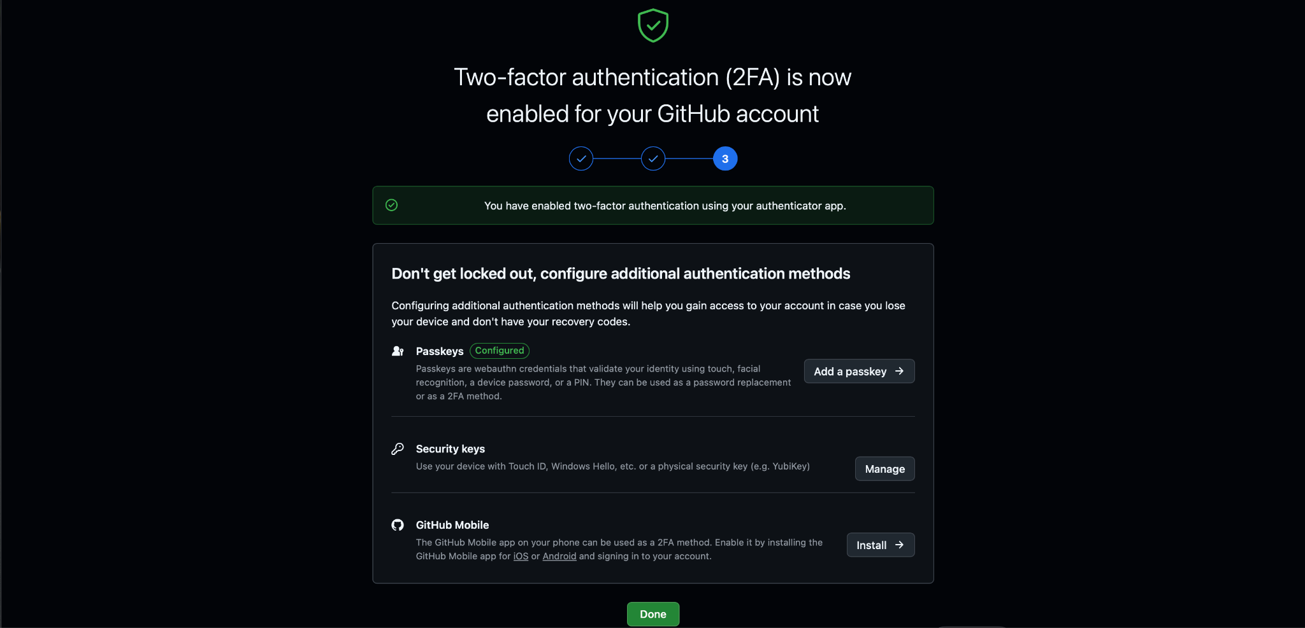

  - Once the set-up is done, you’ll be prompted to save some authentication override codes. Those codes will help in case your third party authenticator fails to authenticate you.
  - Below is a screenshot containing the info of the 2FA, I’ve set-up for my github account
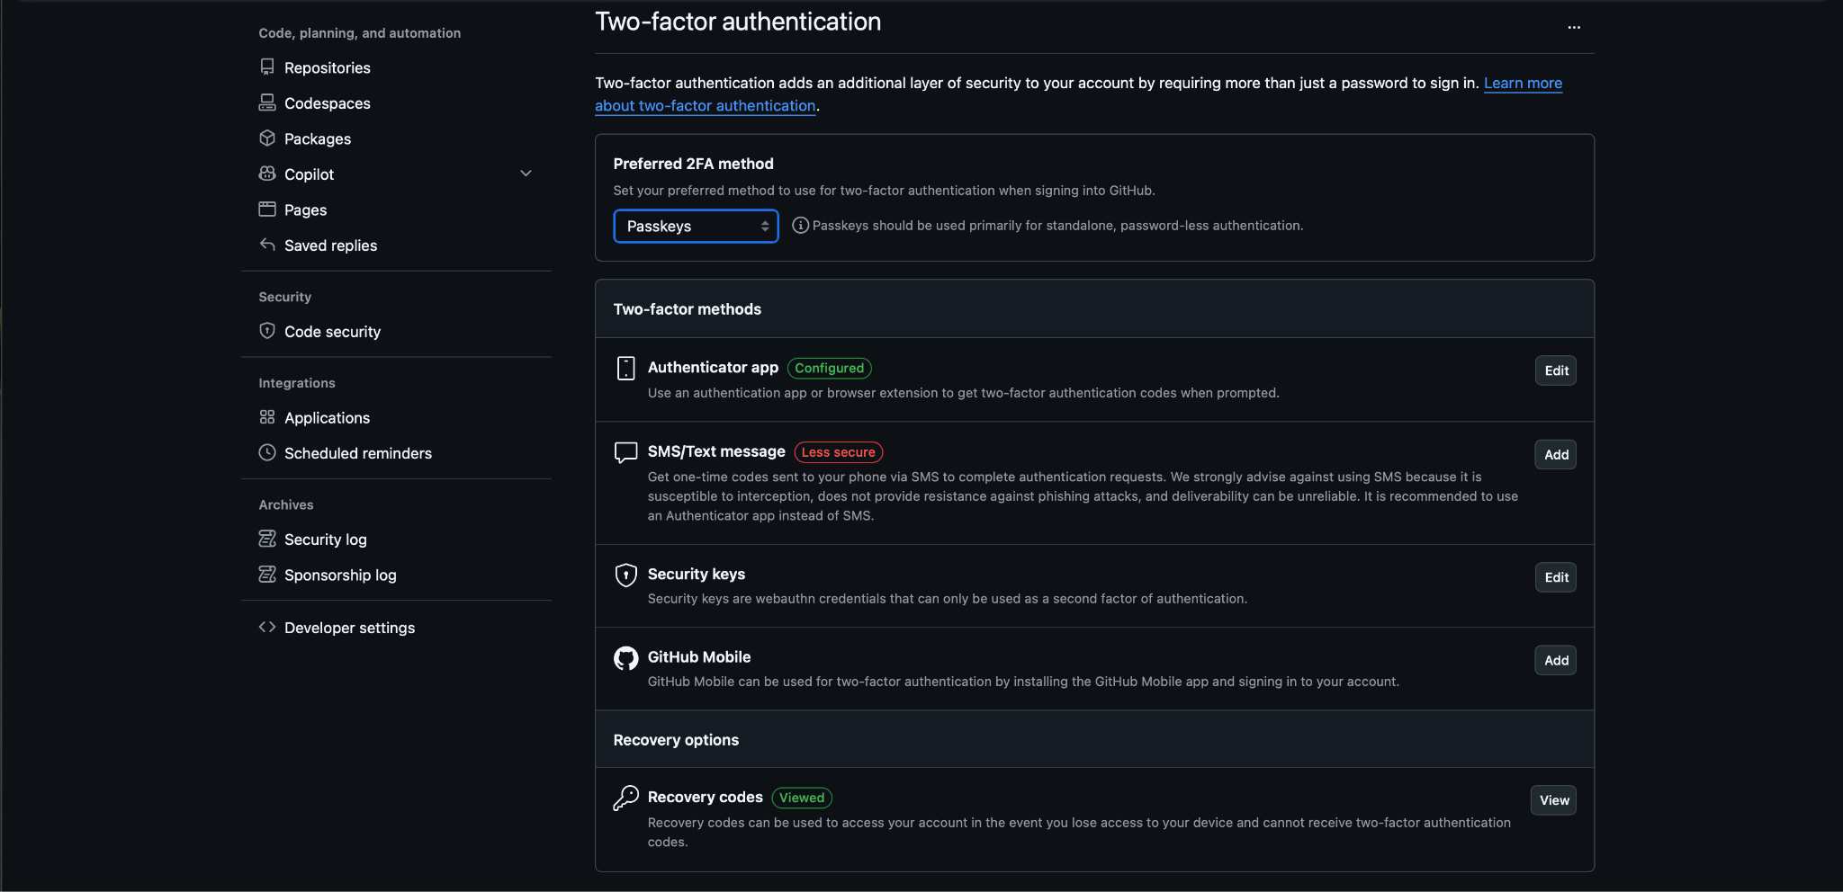

- GitHub SSH Setup from Amazon Linux EC2 - Follow all the below commands and instructions to setup & install git, setup a repository and push your first commit
  - Install Git
sudo yum update -y
sudo yum install git -y
Verify: git --version
  - Configure Git
Replace with your details.
git config --global user.name "rampotnuru"
git config --global user.email "pavanram.potnuru@gmail.com"
Verify: git config --list
  - Create a new SSH key.
ssh-keygen -t ed25519 -C "pavanram.potnuru@gmail.com"
When prompted:
Enter file in which to save the key
Provide a custom filename:
/home/ec2-user/.ssh/git_token
Press Enter.
For passphrase: Press Enter twice to leave it blank.
Expected files:
~/.ssh/git_token
~/.ssh/git_token.pub
  - Verify Key Creation
ls -la ~/.ssh
Expected:
Git_token
Git_token.pub
Known_hosts
  - Display Public Key
cat ~/.ssh/git_token.pub
Copy the entire output.
Example:
ssh-ed25519 AAAAC3NzaC1lZDI1NTE5AAAAI...... pavanram.potnuru@gmail.com
  - Add Public Key to GitHub
Navigate to:
GitHub → Profile → Settings → SSH and GPG Keys
Click:
New SSH Key
Fill:
Title: Amazon Linux EC2
Key Type: Authentication Key
Key: <paste public key>
Save.
  - Configure SSH to Use the Key
Create SSH config file:
vi ~/.ssh/config
Add:
Host github.com
HostName github.com
User git
IdentityFile ~/.ssh/git_token
Save:
ESC
:wq
Set permissions:
chmod 600 ~/.ssh/config
chmod 600 ~/.ssh/git_token
chmod 644 ~/.ssh/git_token.pub
  - Test GitHub Authentication
ssh -T git@github.com
Expected:
Hi rampotnuru! You've successfully authenticated, but GitHub does not provide shell access.
  - Create Project Directory
mkdir bash_scripting
cd bash_scripting
  - Initialize Git Repository
git init
Rename default branch:
git branch -M main
  - Create Project Structure
mkdir scripts
mkdir crontab
Verify:
Tree
Expected:
.
├── crontab
└── scripts
  - Create Repository on GitHub
Create an empty repository named: devops_hub
Do NOT select:
README
.gitignore
License
  - Connect Local Repository to GitHub
Add remote:
git remote add origin git@github.com:rampotnuru/devops_hub.git
Verify:
git remote -v
Expected:
origin git@github.com:rampotnuru/devops_hub.git
origin git@github.com:rampotnuru/devops_hub.git
  - Create First Commit
Create README:
touch README.md
Add files:
git add .
Commit:
git commit -m "Initial commit"
  - Push to GitHub
First push:
git push -u origin main
Subsequent pushes:
git push

- Once the repository is created with the branch ‘main’, go to github.com UI, open the branch devops_hub, you’ll see a button called ‘CODE’, by clicking on it, you’ll get an option to copy the links for cloning. Go to SSH tab and copy the link. This link is used to clone the repository from remote github location to your local machine.
- Now go to your local machine, open command prompt/terminal and navigate to the desired folder to clone the git repo. There, use the below command to clone the repository onto your local machine.
  - git clone git@github.com:rampotnuru/devops_hub.git
- Once the git repo is cloned, the folder can be the origin to your files present in the branch, modifications inside the folder will be reflected into the unstaged area.
- Use the following Bash script to create the entire directory structure in one go.

```bash
#!/bin/bash

mkdir -p devopshub/{\
Linux,\
App-Server-Web-Server,\
Bash-Scripting,\
Git-GitHub,\
AWS/{Cloud-Introduction,Amazon-EC2,VPC,VPC-Peering,IAM,S3,Route53-CDN,CloudWatch-CloudTrail,Auto-Scaling-Groups,Load-Balancers,RDS,Lambda,API-Gateway,KMS,SQS,Amazon-MQ,Secrets-Manager,WAF,Systems-Manager/Parameter-Store,AWS-Architecture},\
Jenkins,\
Docker,\
ECS,\
Terraform,\
Kubernetes,\
ArgoCD,\
Jenkins-Pipeline,\
Prometheus-Grafana,\
Ansible\
}

# Create .gitkeep in every directory
find devopshub -type d -exec touch {}/.gitkeep \;

echo "Directory structure created successfully."
```

### Usage

```bash
chmod +x create-directories.sh
./create-directories.sh
```

This will create:

```text
devopshub/
├── Linux/
├── App-Server-Web-Server/
├── Bash-Scripting/
├── Git-GitHub/
├── AWS/
│ ├── Cloud-Introduction/
│ ├── Amazon-EC2/
│ ├── VPC/
│ ├── VPC-Peering/
│ ├── IAM/
│ ├── S3/
│ ├── Route53-CDN/
│ ├── CloudWatch-CloudTrail/
│ ├── Auto-Scaling-Groups/
│ ├── Load-Balancers/
│ ├── RDS/
│ ├── Lambda/
│ ├── API-Gateway/
│ ├── KMS/
│ ├── SQS/
│ ├── Amazon-MQ/
│ ├── Secrets-Manager/
│ ├── WAF/
│ ├── Systems-Manager/
│ │ └── Parameter-Store/
│ └── AWS-Architecture/
├── Jenkins/
├── Docker/
├── ECS/
├── Terraform/
├── Kubernetes/
├── ArgoCD/
├── Jenkins-Pipeline/
├── Prometheus-Grafana/
└── Ansible/
```

This uses a single `mkdir -p` command with brace expansion, making it concise and easy to maintain.
- This will create a complete directory including all the sub-directories mentioned above.
